

***Addis Ababa Science and Technology University***

*College of Electrical and Mechanical Engineering*

*Department of Software Engineering (3rd Year)*

Human computer interaction Project

Title: **online shopping system UI Design**

**name**  **ID**

Hayelom Kiros 0609/10

Kalu Siyoum 0663/10

Hiluf Tesfaye 0630/10

kaleab melkamu 0651/10

submmited to : mr.Abdurahiman(MSC)

# introduction

This project was proposed for HCI user interface project, to simplify online shopping system

we focused more on user interface than functionality.

because of time constraint. we try to develop user interface of online shopping for clothes and shoes.

UI Design includes:

* + - best authentication page
      * + -sign in
        + 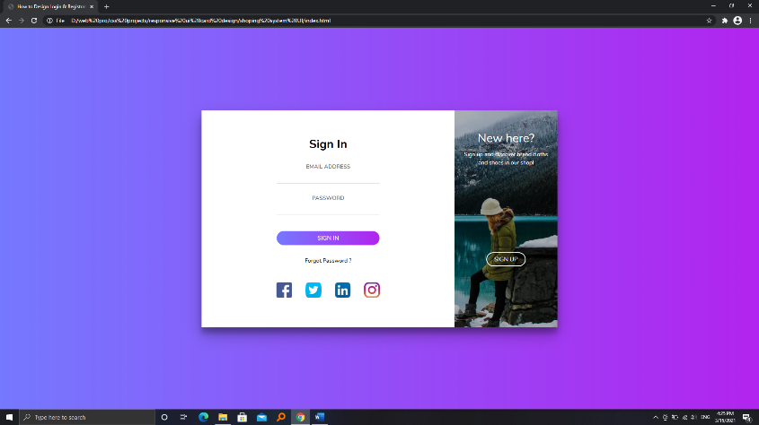
        + -sign up without getting bored with the form

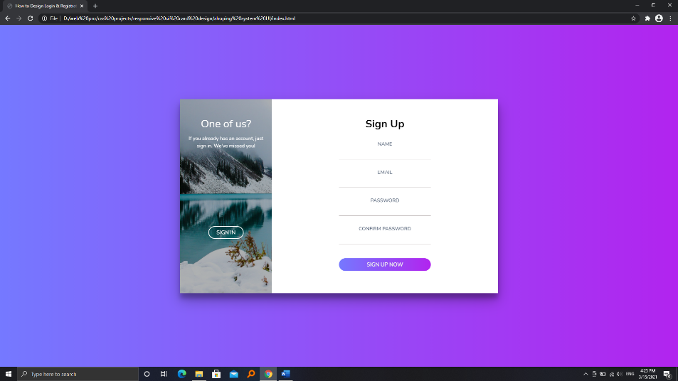

* + - text field and label in the authentication page (login and signup)
    - simplified menu for navigation
      * + 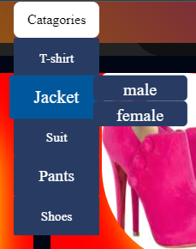
        + since the page is single page, we move easily through categories button
        + 
        + selects where he/she needs
    - simplified Radio Buttons
    - 
    - simplified and new Design Checkbox
    - 
    - Nice and interesting buttons which focuses eye contact
    - new scroll bar which shows the progress of user in our page
    - this page single Page web with dynamic interaction

Note: this web Page is Interactive and Responsive (different screen size from small screen to large screen devices).



